Practical - 5
Practical Title: Registration Form with Frontend Validation and User-Friendly Error Handling

Problem Definition: Create a student registration form with HTML5 input types and JavaScript validation for name, email, mobile number, password, confirm password, course, year, gender, and terms acceptance. Use Regular Expression for validations.

Theory
- Are correct input types and attributes used?
Answer:
Yes. The form uses appropriate input types such as email, tel, and password. Attributes such as name, id, and value are also used so that the form data can be identified and processed correctly. HTML input types also help browsers provide suitable validation and input controls.
Reference: W3C – Validating Input

- Are validation errors displayed near the relevant fields?
Answer:
Yes. Validation errors are displayed near their respective fields using elements such as nameError, emailError, mobileError, and passwordError. This makes it easier for users to identify and correct the specific input that contains an error. Reference: W3C – Validating Input

- Is password strength checked?
Answer:
Yes. The password is checked using a regular expression. It must contain at least 8 characters, including an uppercase letter, lowercase letter, number, and special character. This ensures that weak passwords are rejected during form validation. Reference: W3C – Form Instructions

Is the form accessible using keyboard and screen-reader-friendly labels?

Answer:

The form uses standard HTML controls such as inputs, radio buttons, checkboxes, select menus, and a submit button, which can be operated using the keyboard. It also provides visible labels for the form fields. For better screen-reader accessibility, each <label> should be explicitly associated with its input using matching for and id attributes.

Reference: W3C – Labeling Controls

Result

The StudentHub registration page is now more accurate using javascript and drop down and other tags using regex in email and passwords to store proper data

Evidence of Work (Screenshots)
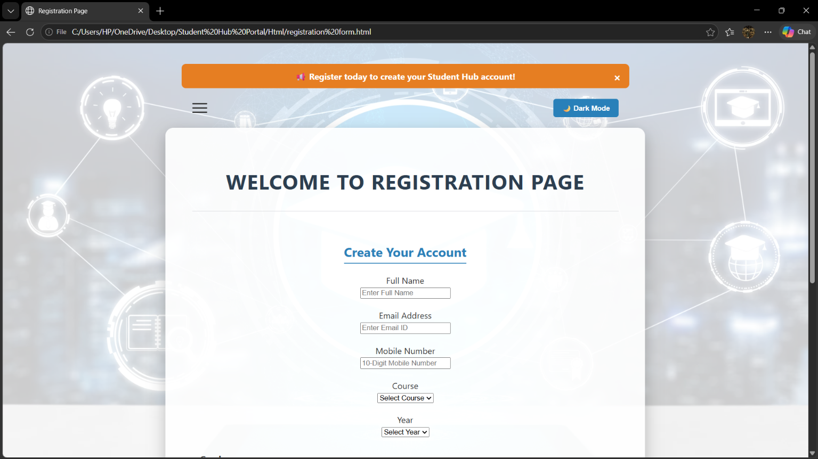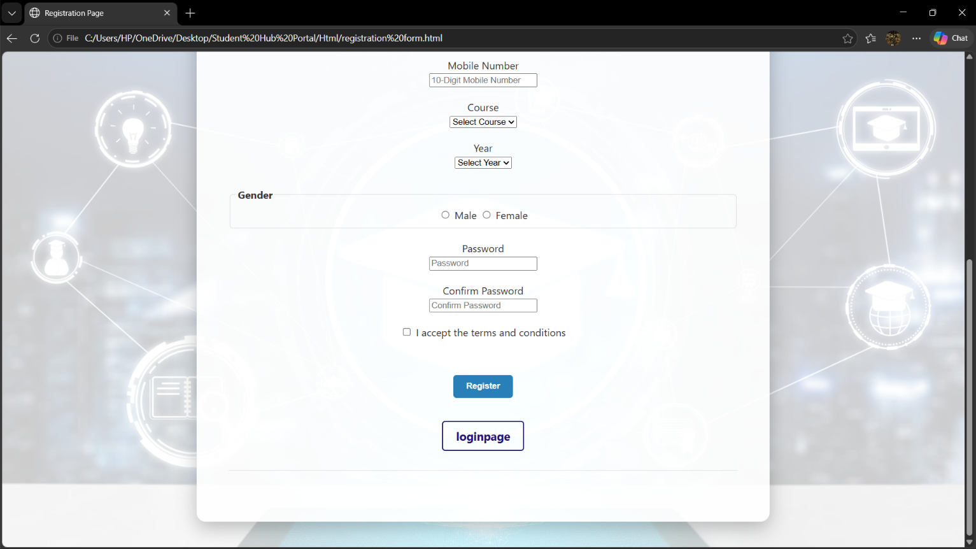

GitHub Repository Link:
https://github.com/RajMonani/Student-Portal-Hub

Challenges Faced:

In this practical the challenges I faced were the regex when I was entering the regex expression it still wasn’t detecting it and the issue was the id name in html and javascript had a spelling difference

Learning Outcomes:

After this practical I learn how to use diff javascript concepts such data entering in file so that it can radio buttons dropdown menu and regex expressions how to create them

Faculty Remarks:

